# The Difference Between Document and Window Objects in JavaScript

Understanding the Document and Window objects in JavaScript programming is crucial for creating efficient web applications, as they serve distinct purposes and have unique properties.

## **Document Object**

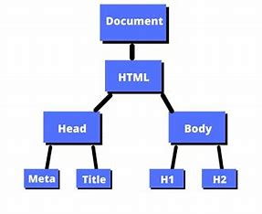

The Document object is a web page's HTML document, serving as an interface for JavaScript to interact with and manipulate elements within the document structure.

1. **Representation of HTML Structure:** The Document object provides access to the HTML structure of a web page, including elements like `<html>`, `<head>`, `<body>`, and all other HTML elements present in the document.

2. **Methods for Element Selection and Manipulation:** It offers methods such as `getElementById()`, `getElementsByClassName()`, `getElementsByTagName()`, and `querySelector()` to select and manipulate specific elements within the document.

3. **DOM Manipulation:** Through the Document Object Model (DOM), JavaScript can dynamically modify the content, structure, and style of HTML elements, allowing for interactive and responsive web applications.

4. **Event Handling:** The Document object facilitates event handling by allowing JavaScript to attach event listeners to elements and respond to user interactions like clicks, mouse movements, and keyboard inputs.

## **Window Object**

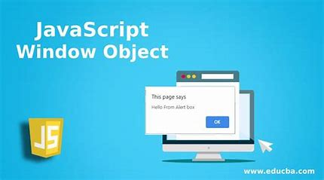

The Window object is a global object in client-side JavaScript, containing the browser window containing the Document object, offering access to various browser functionalities and properties.

1. **Global Scope:** All JavaScript code executed in the browser window operates within the context of the Window object. Global variables and functions are properties and methods of the Window object.

2. **Browser Window Properties and Methods:** The Window object provides properties and methods to control the browser window itself, such as `window.innerWidth`, `window.innerHeight`, `window. open()`, `window. close()`, and `window. location`.

3. **Navigation and History:** It enables navigation within the browser window through methods like `window. location`, `window. history`, and `window. navigator`, allowing developers to control the URL, history, and browser settings.

4**. Timers and Intervals:** The Window object includes methods like `setTimeout()` and `setInterval()` to execute code asynchronously after a specified delay or at regular intervals.

## **Key Differences**

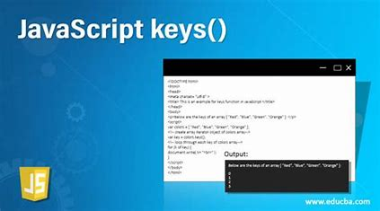

1. **Scope:** The Document object represents the content of the HTML document, while the Window object represents the browser window itself.

2. **Hierarchy:** The Document object is nested within the Window object, as the content of the document resides within the browser window.

3. **Access to DOM vs. Browser Window:** The Document object provides access to the HTML structure and elements of the document, while the Window object provides access to browser-specific properties, methods, and functionalities.

4. **Manipulation vs. Control:** While the Document object focuses on manipulating the content and structure of HTML elements, the Window object primarily controls the behavior and appearance of the browser window.

Understanding the differences and capabilities of Document and Window objects is crucial for effective web application development and interaction with the browser environment.